**SOLUTION TO PROBLEM PROGRAMME:** BSSE/BSCS/BIT

**YEAR/SEM:** YEAR 2 SEM 1

**COURSE CODE:** BIT2115

**PROBLEM NAME:** COMPLETE NAME OF PROBLEM

STUDENT DETAILS:

|  |  |
| --- | --- |
| **NAME OF STUDENT** | EMMANUEL KUAL MAGOK |
| **REG NUMBER** | 24/789/BSS-J |

**SOURCE-CODE SCREENSHOT**

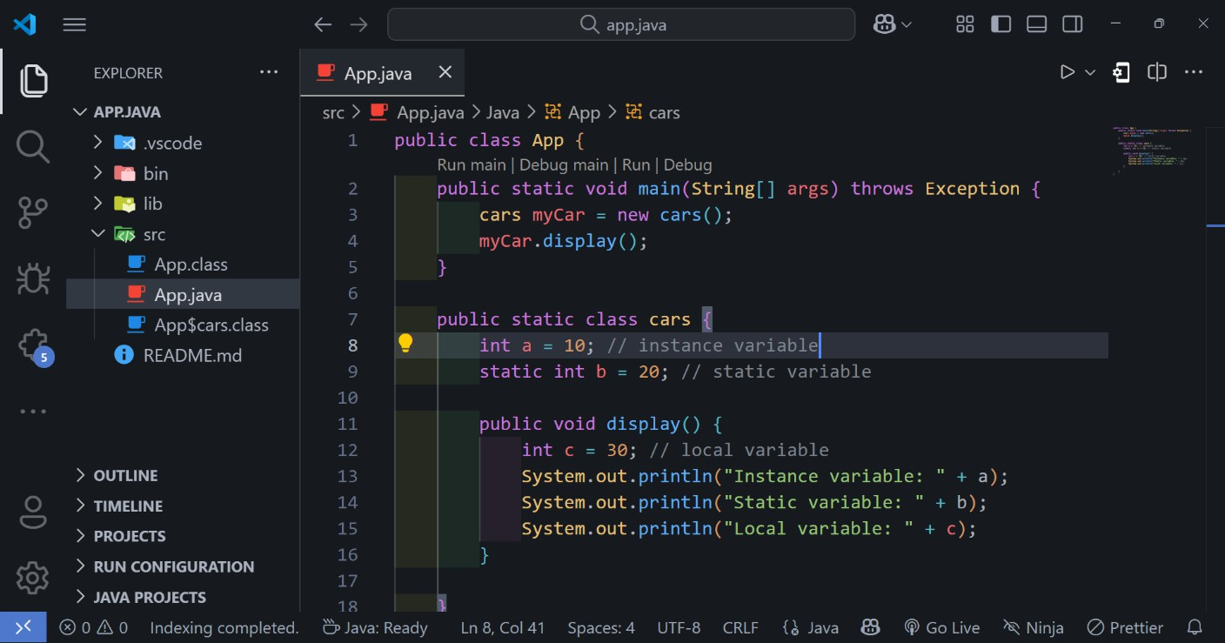

**Detailed explanation**

|  |  |
| --- | --- |
| Line of codes | Explanation |
| #7 | This line declares a public class named “Cars” |
| #8 | This line declares an instance variable named “a” |
| #9 | This line declares a static variable named “b” |
| #11 | This line declares a method named “display” |
| #12 | This line declares a local variable named “a” inside the method called “display” |
| #13-15 | These lines print out the instance, static and local variables |

**OUTPUT SCREENSHOT**

